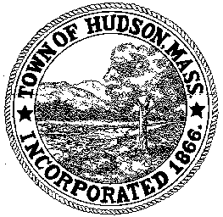

CONSERVATION COMMISSION
78 Main Street, Hudson, MA 01749
(978) 562-2020

Paul Byrne, Chairman W. Minot Wood, Vice Chairman David Esteves, Member

Terrence Joyce, Member Leif Longtine, Member Joseph Rodrigues, Member Al Tashian, Member

Meeting Agenda
January 19, 2012 7:00 P.M.

- Preliminaries
  - Open Meeting
  - Roll Call

2.0 New Business
2.1 RDA 419
Applicant: Sudbury Valley Trustees
Location: Property Abutting 153 Forest Avenue
Project Description: removal of 3 to 4 dead trees

2.2 Minutes – January 5, 2012

3.0 Old Business
3.1 Discuss Otsego Drive

4.0 Correspondence
4.1 Chestnut Street Culvert
4.2 Brook Street
4.3 Lycott Environmental – Final Report for Treatment

5.0 Adjournment

Next Meeting: February 2, 2012

